Case study: NHS England Advanced Community Pharmacy Smoking Cessation Service – The Royal Wolverhampton NHS Trust

# Executive Summary

The New Cross Hospital (part of the Royal Wolverhampton NHS Trust (RWT)) is located in Wolverhampton, West Midlands. The trust started to refer patients who had quit smoking as an inpatient to community pharmacies across Wolverhampton and nationally in January 2023. This is part of the NHS England Pharmacy Integration Programme [NHS Smoking Cessation Service: Transfer of Care to Community Pharmacy from Secondary Care.](https://www.england.nhs.uk/primary-care/pharmacy/pharmacy-integration-fund/nhs-smoking-cessation-transfer-of-care-pilot-from-hospital-to-community-pharmacy/)

The Smoking Cessation Service (SCS) is based on the [NICE guidelines on tobacco uptake, quitting, and dependence](https://www.nice.org.uk/guidance/ng209), referenced in the [NHS Long-Term Plan](https://www.longtermplan.nhs.uk/online-version/chapter-2-more-nhs-action-on-prevention-and-health-inequalities/smoking/). This establishes the smoking status of all admitted patients followed by brief advice, personalised bedside counselling, timely nicotine replacement therapy (NRT) or pharmacotherapy, and follow-up after discharge.

The referral pathway aims to ensure patients’ quit attempts are assisted following discharge with behavioural support and NRT product supply, which we know means that [smokers are three times as likely to quit](https://www.ncsct.co.uk/publications/Stop_smoking_services_impact_on_quitting).

Referrals to community pharmacies for smoking cessation were vital as Wolverhampton Local Authority does not currently commission a community stop-smoking service. Therefore, patients who have quit smoking during an inpatient stay at New Cross Hospital needed an option of continuing support post-discharge at a location convenient to the patient through a community pharmacy.

# Background & Pathway Implementation

The [CURE model for smoking cessation](https://gmcancer.org.uk/programmes-of-work/treatment/the-cure-project/) is NHS England’s nearest adaptation of the Ottawa Model of Smoking Cessation (OMSC). This model is a validated, evidence-based process to implement smoking cessation treatment and support as part of routine care in various healthcare settings, including hospitals.

As part of the service implementation across England, NHS Midlands and Lancashire Commissioning Support Unit (MLCSU) was commissioned by NHS England (NHSE) to support implementation.

A three-stage process was mapped for a local trust/system to go live with the service. This is outlined below.

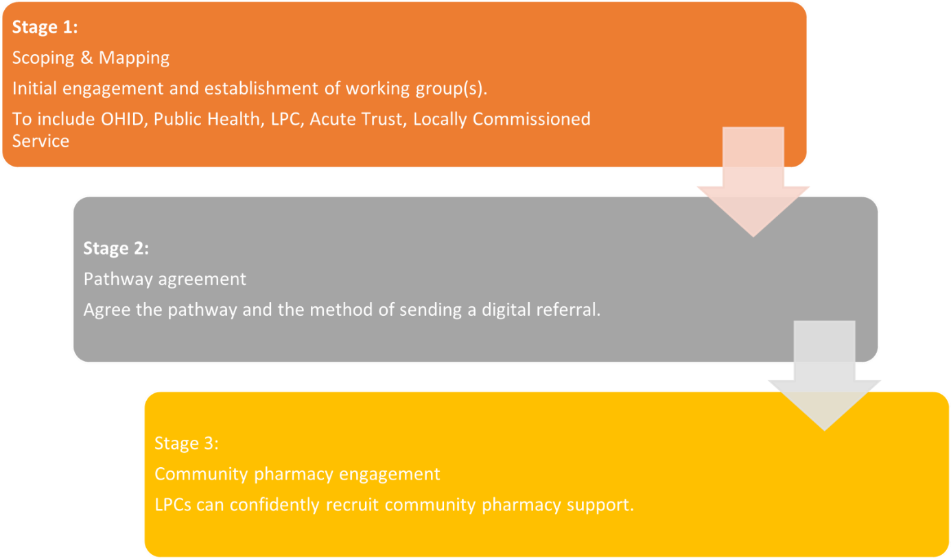

## Stage 1

MLCSU, working closely with Pharmacy Integration Fund (PhIF) leads, Office for Health Improvement and Disparities (OHID), and NHS Prevention Programme Leads, mapped current and planned progress of Acute, Community, and Mental Health Trusts to the Long-Term Plan requirements of implementing inpatient tobacco dependence services in each trust.

Initially focusing on those trusts who already had their tobacco dependence teams in place, or who were close to being in place, MLCSU identified the key stakeholders within the trust and wider locality, including representation from public health, Integrated Care Board (ICB), and Local Pharmaceutical Committee (LPC) members. Once the trust had agreed on an intention to implement, a working group was established to oversee the implementation.

For RWT the working group consisted of the trust tobacco programme manager, LPC chief officer, Wolverhampton Council NHS Living Well programme manager, lead cardiology rehabilitation nurse and clinical pharmacist, trust finance, and business intelligence/data team. Steering group meetings were held fortnightly from September to January 2022 until the inpatient service went live, with follow-up meetings continuing with a smaller stakeholder group until March 2023.

## Stage 2

MLCSU provided support to the trust to identify the most appropriate referral pathway for the tobacco trust team (currently via secure NHS mail or a digital referral platform) and facilitated the set-up of the pathway where possible.

The trust decided to procure the license to send referrals digitally via the electronic referral system to community pharmacies. MLCSU was able to support this by putting the trust team in touch with the digital referral system services team to start the license-purchasing process. This software benefited the trust by allowing the trust tobacco team to capture an audit trail of each patient referred to the community pharmacy. This was achieved through downloading reports and enabling the team to submit data returns as part of the NHS Long-Term Plan.

The trust opted to go live with the service through a phased approach. They audited their NRT prescribing and concluded that cardiac rehabilitation would be an ideal directorate to start the service before expanding trust wide. The cardiac rehab nurses would at the beginning of the service refer suitable patients to community pharmacies with tobacco dependency advisors leading on referrals once in post and trained.

## Stage 3

The LPC was engaged with implementation at the start of the process and provided updates on the progress of NHS SCS implementation to the pharmacy contractors through LPC newsletters. A community pharmacy engagement webinar was held, attended by MLCSU, LPC, Trust cardiac rehab pharmacist and lead nurse, a team member from the digital referral system, and the Living Well programme manager for tobacco dependence. The session provided valuable information for contractors, including lessons learned from other regions who had gone live, and addressed questions contractors had. A recording of the webinar was made available for those unable to attend and this was shared with all contractors across Wolverhampton and neighbouring areas by the LPC.

# Outcomes

* 433 patients referred to community pharmacies over 12 months (Jan-Dec 2023)
* 75% of those patients referred to the community pharmacy stop smoking service engaged with a supported quit attempt
* Patient information was sent via the digital referral system from the hospital smoking cessation team to the participating community pharmacy of the patient’s choice
* Patients were followed up by the pharmacy within five days of the referral being sent, with the first consultation in the pharmacy usually taking place within two weeks of discharge, to ensure there is no disruption in the NRT supply
* 47% of patients achieved a 28-day quit rate ([comparable to national NHS stop-smoking statistics](https://digital.nhs.uk/data-and-information/publications/statistical/statistics-on-nhs-stop-smoking-services-in-england/april-2022-to-march-2023-q4#data-sets))
* 25% of patients recording a 4-week quit also went on to record a 12-week quit.

# RWT NHS SCS Go Live Activity (Jan – Dec 2023)

## Total Referrals

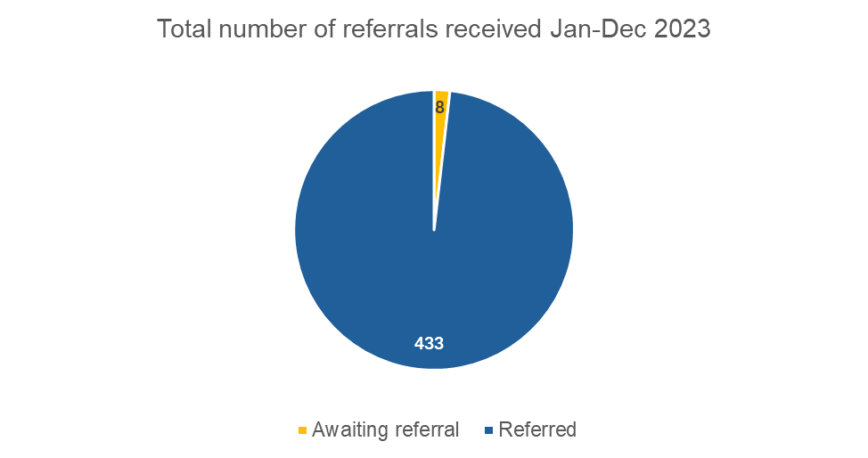

## Referral Outcomes

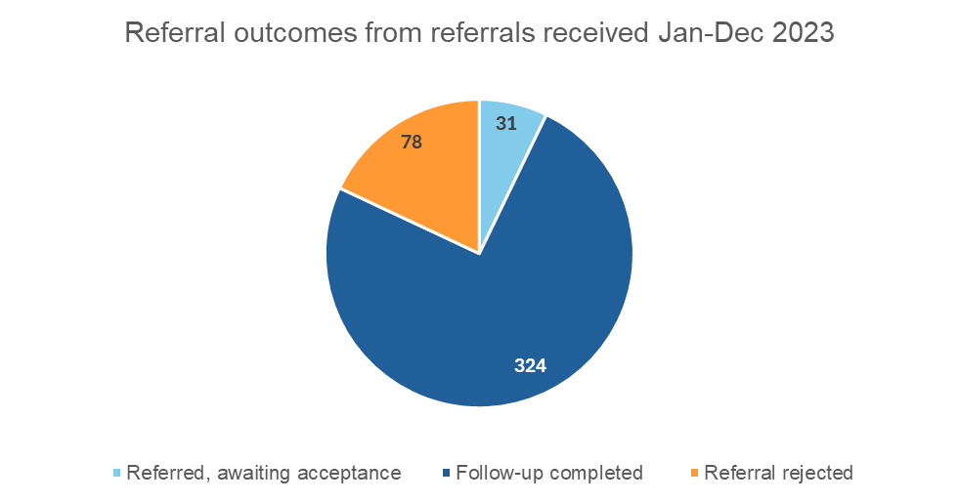

“Follow-up completed” is defined as - **“**When a referral is received, the patient attends”

## Community pharmacy referral rejection reasons (see troubleshooting section for more information)

* Staff were unaware of the service
* Staff trained to provide the service were unavailable due to leave, sickness, etc
* Staff still need to complete the National Centre for Smoking Cessation and Training (NCSCT) to provide service
* Pharmacy has de-registered from the service
* Staff who have trained to provide the service no longer work in the pharmacy

## Cumulative Referrals & Follow Ups



Number of referrals

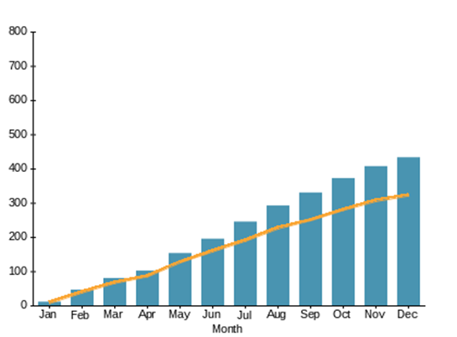

If a service is aiming to maximize the number of referrals made, then the overall height of the bars in the left-hand chart above should be increasing from left to right and the right-hand chart above should show an upward concave curve.

## Patient Journey

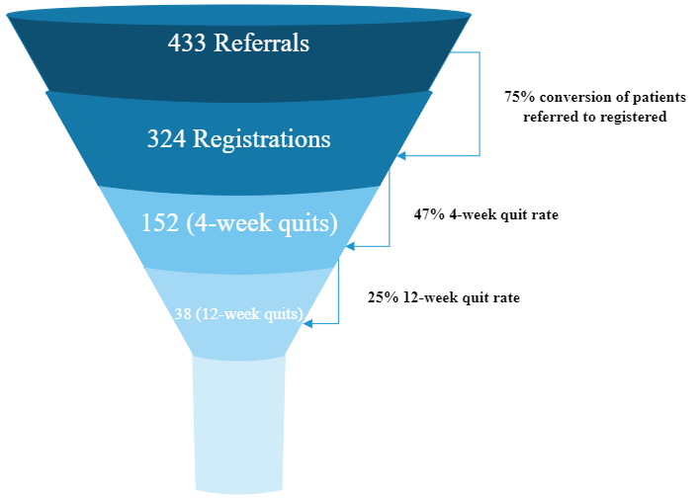

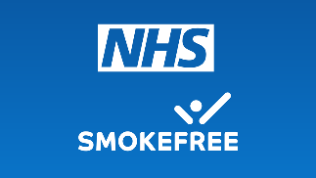

# Patient Quotes

**“**The programme has helped me understand the importance of quitting smoking without unrealistic expectations and without any added pressure”

Patient – LD, Age 50

“I can’t speak highly enough of the team they explained everything so clearly, while my health isn’t 100% back to normal I do feel my health has improved. I felt as though I can really make the change”

Patient – TS, Age 72

# Trust & Community Pharmacy Feedback

## Ellina Bawa (Tobacco Dependency Programme Manager), Eileen Perry & Godfrey Chiworeka (Tobacco Dependency Advisors – RWT)

“Before launching the service, we started by contacting community pharmacies signed up to the Advanced Service and offered to meet with them face to face to offer additional support and information about the service. Meeting face-to-face with pharmacies has been highly welcomed and has led to the formation of effective collaborative relationships which has supported us in generating a live list of pharmacies that were able to accept referrals.

To strengthen our relationships with community pharmacies having contact with Jeff from the LPC has been extremely important. We have regular meetings with representation from LPC and ICB, where we discuss service development, additional support needed, and problems being faced.  We contact community pharmacies before referring a patient at discharge and continue to build relationships to ensure there is a continuation of care when the patient is discharged from the hospital.

We are seeing on a day-to-day basis the benefit this service is having on our patients, through feedback whilst they are in the hospital or after they have been discharged. Hopefully, we have helped them with their long-term health condition management, improved their quality of life, and reduced the likelihood of premature death.”

## Shamma Khan – Senior Pharmacist, Cardiac Services. Royal Wolverhampton NHS Trust

“The Tobacco Dependency Service is incredibly valuable and vital. It has been a huge success in ensuring our patients are managed appropriately and followed up. Thanks for all your help.”

## Baldeep Dhariwal (Pharmacist, Rexall Pharmacy)

“As a community pharmacist operating the stop smoking service, I have always found the colleagues at the tobacco team friendly, easy to communicate with, and cooperative.

They also give the patients a good grounding in how the service works and treatment options available to them, thus making the continuation of the service in the community seamless and straightforward as I don't need to duplicate the counselling work.”

# Troubleshooting

As with any new service, there have been some teething problems with the referral pathway, and subsequent service delivery by community pharmacy.

The trust tobacco programme manager was proactive in supporting community pharmacies to adopt this new service. The manager would do site visits to registered pharmacies to get early engagement. This helped to ensure that pharmacies were ready to provide the new service and had access to all the information and resources available. In addition, the manager would review the electronic referral data regularly and call pharmacies that had received referrals in the early days of service activity. This was to prompt action on referrals that had been sent.

The LPC also worked closely with the trust tobacco team and continued with regular contact via email and telephone to raise and address any issues that have arisen:

|  |  |
| --- | --- |
| **Issues** | **Mitigation & Support** |
| Some challenges with pharmacy responsiveness to referrals | * The service was new and launched at a very busy time for community pharmacies with winter pressures – it took time to embed * LPC and trust tobacco team regularly monitors data to understand the referrals made and response rate by community pharmacy * Phone calls are made by the LPC and trust tobacco team to check in with pharmacies who have not yet actioned referrals * LPC provides newsletters for pharmacies to highlight service * Recommendation - to involve pharmacy staff to handle appointments and engage with patients |
| Pharmacists are finding it hard to engage referred patients with the service | * Emphasise the flexibility of the service to patients * Offer face-to-face, video, and telephone consultations * Offer flexible weekly or fortnightly appointments * Ensure all pharmacy staff are briefed on the service and can confidently talk to patients about the service |
| Changes in personnel since registration have led to some pharmacies not having trained pharmacy staff in place to deliver the service | * SCS is an advanced service, which means it is optional for a pharmacy to sign up, if a pharmacy is unable to deliver the service currently, it can de-register * Pharmacy engagement webinars held to brief on the service, and provide information about training and service delivery are available as recordings by the LPC * NCSCT training is readily available for pharmacy staff to complete |

# Take away tips

## For community pharmacy teams:

1. [NCSCT resources](https://www.ncsct.co.uk/), e-learning, and practitioner certification. Consider completing the e-learning in preparation for the advanced service, if you have not done so already
2. Find out if there is a locally commissioned stop-smoking service in your area, which could complement the new referral pathway. Your LPC should be able to help
3. Ensure consumables like carbon monoxide (CO) monitor (service compliant according to service specifications) are available along with mouthpieces
4. Involve your team in managing appointments and contacting your patients to spread the workload
5. Get your team involved to support very brief advice (VBA) conversations around smoking with patients. There is e-learning on the [NCSCT website](https://www.ncsct.co.uk/) and information on the [CPE website](https://psnc.org.uk/services-commissioning/essential-services/healthy-living-pharmacies/guidance-and-resources/) which includes links to information and guidance from [NICE (National Institute for Health and Care Excellence)](https://www.nice.org.uk/guidance/ng102)  and [RSPH (Royal Society for Public Health)](https://www.rsph.org.uk/our-work/policy/wider-public-health-workforce/measuring-public-health-impact.html)
6. Check with your LPC what plans are being developed to roll out the Stop Smoking Advanced Service in your area

## For hospital teams:

1. Make as much effort as possible to ensure the patient is contactable after discharge: check the telephone number is correct, ask when is best to call, have an alternative number, and gain consent to send text messaging. Ask the patient to add the pharmacy telephone number to their phone if they do not answer unrecognised numbers
2. Provide the patient with the telephone number of the chosen pharmacy in case they do not hear from them
3. Build relationships with registered pharmacies during implementation or early stages of going live as this will increase engagement and help to ensure referrals are picked up promptly until the service becomes business as usual for the pharmacy
4. Ask patients which pharmacy they usually use and see if the advanced service is available there – patients often like to use the pharmacy they are familiar with

# Conclusion

The success of this referral pathway implementation has demonstrated the need for local stakeholder engagement and participation in the implementation stage, particularly with Wolverhampton LPC, the Acute Trust, and community pharmacies. Collaboration to create the integration of the service across the acute trust and community pharmacy has been essential.

A phased approach was crucial in helping the trust get used to the process of referring patients to community pharmacies. In addition, it gave capacity for community pharmacies to receive referrals in a manageable way to get used to providing the service with their business-as-usual demands.

The tobacco programme manager coming into the post took the initiative to build relationships with registered community pharmacies within Wolverhampton and worked closely with the LPC to encourage more community pharmacies to sign up to deliver the service.

The lack of a locally commissioned community stop-smoking service has been an influence on the volume of referrals sent by New Cross Hospital, having no other option (other than self-care) for Wolverhampton residents at discharge.

The support and input of the LPC have been invaluable to the successful activity seen to date.

## For more information please contact:

Rob Hebdon – National Pharmacy Integration Lead

Email: [rob.hebdon1@nhs.net](mailto:rob.hebdon1@nhs.net)

Mobile: 07585 960136

NHS Midlands & Lancashire Commissioning Support Unit

Email: [mlcsu.medicines-management@nhs.net](mailto:mlcsu.medicines-management@nhs.net)